|  |  |
| --- | --- |
| logo | Year 9 Science  **Biology 2 Test: Ecology** |

**SECTION 1: MULTIPLE CHOICE** (1 mark each)

Circle your answer on the multiple choice answer sheet.

1. Which term does not refer to a type of symbiotic relationship?

a. commenalism

b. mutualism

c. parasitism

d. predation

2. In an ecosystem, producers are

* 1. Any organism
  2. Any organism that obtain energy.
  3. Any organism that obtains energy from other organisms.
  4. Any organism that produce their own food.

3. The diagram below shows a food web found in a particular ecosystem.

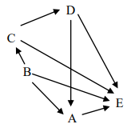

From this diagram, we can conclude that A, B and C, respectively are:

a) A producer, a herbivore and a decomposer

b) An omnivore, a producer and a herbivore

c) A decomposer, a carnivore and a producer

d) A herbivore, a decomposer and an omnivore

4. Organism E in question 1 is:

a. A producer

b. A herbivore

c. A decomposer

d. A carnivore

5. Some materials can be harmful to the organisms in the food web. Which of the following explains why DDT is particularly dangerous in food webs?

a. It kills insects when it is sprayed on them

b. It accumulates and concentrates while passing along a food chain

c. It becomes more poisonous when it passes through a living thing

d. DDT is a toxic chemical and any toxic chemical is dangerous to use

6. The source of energy for consumer organisms is:

a. oil and coal

b. food they eat

c. heat from the sun

d. oxygen in the air

7. The picture shows a pond and some of the organisms that live in and around the pond that depend on each other for food. The TADPOLE most likely gets its food from which of the following?

|  |  |
| --- | --- |
| a. a food source not shown on this diagram  b. sun  c. fish  d. duckweed plant | 4E628F1E |

8. David visits regularly visits Cape Le Grande National Park with his family. Over the course of a number of visits he observes a Marbled Gecko eating a spider and later a Wedge Tailed Eagle eating a Marbled Gecko. This is an example of a:

a. ecosystem

b. food web

c. food chain

d. biosystem

1. 9. Look at the food chain shown. Using the information in the food chain, determine which statement is NOT a correct inference.

c*lover* → *caterpillar* → *lizard* → *kookaburra*

a. The lizard consumes the caterpillar.

b. The clover is the producer.

c. The kookaburra is dependent on the clover.

d. There would be a greater mass of kookaburras than lizards.

1. 10. From the following lists, choose the one that only contains physical (abiotic) factors.

a. rainfall, sunlight, competition, soil nutrients

b. temperature, wind speed, predation, humidity

c. soil moisture, sunlight, air temperature, soil texture

d. pollination, parasitism, humidity, soil humus content

1. 11. Identify which of the following is a structural adaptation of a kangaroo.

a. On very hot days it licks its forearms to allow them to cool by evaporation.

b. It hides in caves or under trees on hot days.

c. It digs to find water in dry creek beds.

d. It has a long heavy tail that balances its body when it hops.

12. In the water cycle, the majority of the water exists as

a. sea water.

b. water vapour in air.

c. clouds.

d. part of living things.

13. Biodiversity is

a. a wide variety of different living things.

b. a balance that can be maintained or supported for a long time to come.

c. when one species survives because it is more suited to its environment that another.

d. a measure of the number of individuals of one species living in an area.

14. **The next three questions refer to the following diagram**

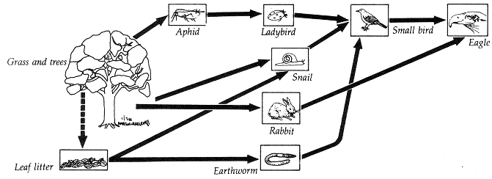

15. The producer(s) in this ecosystem are

a. grass and trees.

b. leaf litter.

c. aphids, rabbits and snails.

d. eagle

16. The ladybird is

a. primary consumer.

b. a secondary consumer.

c. a tertiary consumer.

d. an omnivore.

17. Which organism is a decomposer?

a. leaf litter

b. earthworm

c. eagle

d. small bird

18. Which of the following is least likely to upset the natural balance of an ecosystem?

a. Killing off or removing all of one species of plant or animal.

b. Introducing a new pest insect.

c. Climate change caused by carbon emissions and global warming.

d. Seasonal changes in temperature and rainfall.

19. In an ecosystem, the species that there are fewest of, or have the smallest biomass are

a. the producers.

b. the first order (primary) consumers.

c. the second order (secondary) consumers.

d. the higher order consumers.

20. Animals and plants are made up of a number of different chemical elements and compounds. What happens to all of these substances when animals and plants die?

a. they die with the animal or plant

b. they evaporate into the atmosphere

c. they are recycled back into the environment

d. they change into different elements

**MULTIPLE CHOICE 20 MARKS**

|  |  |
| --- | --- |
| 1. A B C D 2. A B C D 3. A B C D 4. A B C D 5. A B C D 6. A B C D 7. A B C D 8. A B C D 9. A B C D   10. A B C D | 11. A B C D  12. A B C D  13. A B C D  14. A B C D  15. A B C D  16. A B C D  17. A B C D  18. A B C D  19. A B C D  20. A B C D |

**WRITTEN SECTION**

1. The following paragraph describes the feeding relationships in a community found in the Western Australian desert.

*Spinifex and Mulga are plants that are eaten by beetles. In turn, beetles are eaten*

*by spiders, lizards, and assassin bugs. Lizards are eaten by goannas and dunnarts.*

*Dunnarts also eat beetles and assassin bugs and themselves are eaten by goannas.*

* 1. Name one herbivore from this community ___________________________________(1 mark)
  2. Name one carnivore from this community ___________________________________(1 mark)
  3. Starting with a producer, draw a food chain of four organisms from the community described above. (2 marks)
  4. In some parts of Western Australia, feral goats have invaded communities like this one and eaten much of the Mulga. What effect is this likely to have on the beetles? (1 marks)

* 1. Draw a food pyramid for the following organisms from the community. (2 marks)

Beetles Lizards Spinifex Goannas

* 1. Fill in the missing organisms in the food web below. (2 marks)

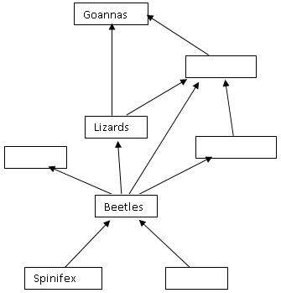

* 1. If goats entered this community and ate much of the Mulga, what would be the likely effect, in the long term, on the number of dunnarts? (3 marks)

(NOTE: goats are herbivores and dunnarts are small mouse like animals)

_____________________________________________________________________________________

Explain your reasoning.

______________________________________________________________________________________________________________________________________________________________________________________________________________________________________________________________________________________________________________________________________________________________________________________________________________________________________________________________________________________________________________________________

22.

1. Observe the diagram below of an aquarium.

List two **biotic** and two **abiotic** factors in the aquarium ecosystem. (4 Marks)

